July 25, 2025
Kaydeen Integrated Services Ltd (RC 8391078),
No 2 Green Lane Akintayo Estate,
Bode Basorun,
Ibadan, Oyo State.
LETTER OF ENGAGEMENT FOR AIR CONDITIONING (AC) MAINTENANCE SERVICES
Dear Sir/Madam,
We are pleased to formally engage the services of Kaydeen Integrated Services Ltd. as the official Air Conditioning (AC) Maintenance Vendor for the Ilorin Innovation Hub.
This engagement covers the following scope of work:
- Quarterly Preventive Maintenance
  - Scheduled quarterly servicing of all AC units within the Ilorin Innovation Hub facility, including cleaning, performance checks, and routine diagnostics.
- Repairs and Corrective Maintenance
  - Timely assessment and repair of any AC unit(s) requiring attention, with prior notification and cost estimates submitted to the Hub for approval before proceeding.
All works must be carried out by qualified technicians under your supervision and in accordance with standard safety and professional maintenance protocols. We expect professionalism, reliability, and clear communication throughout the course of this engagement.
This engagement shall take effect from the date of this letter and shall remain valid until otherwise reviewed, renewed, or terminated by either party with due notice in writing.
Kindly confirm your acceptance of this engagement by signing and returning the duplicate copy of this letter.
We look forward to a smooth and productive relationship.
Yours faithfully,
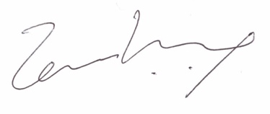
Temi Kolawole
Managing Director
Acknowledgement and Acceptance
We, Kaydeen Integrated Services Ltd., accept the terms of this engagement as outlined above.
Name: __________________________
Designation: _____________________
Signature: _______________________
Date: ___________________________

